**ABSTRACT**

Online food ordering management system is a software used to ease the customer’s life. Sometimes you don’t feel like cooking or doesn’t feel like to go to the restaurants, therefore we here propose an Online Food Ordering Management System which can help the customers to get food delivered immediately. This is mostly designed for a single restaurant having various food items at valuable food price. It gives effective way to order your food and almost within no time food will be delivered. Customer, he/she has login form with password in order to secure the information details and then they can select his/her favorite food items, place the order, also mention the quantity and finally can make the payment. When the order is placed, it gets stored in the database of the restaurants and then the staffs go through the orders and processes it efficiently..

**TABLE OF CONTENTS**

|  |  |  |
| --- | --- | --- |
|  | **CONTENTS** |  |
|  | **ABSTRACT** | **iv** |
|  | **LIST OF FIGURES** | **viii** |
| **1.0** | **INTRODUCTION** | **1** |
|  | 1.1 Admin Module | 1 |
|  | 1.2 User Module |  |
|  | 1.3 System Requirements |  |
|  | 1.4 Existing System | 1 |
|  | 1.5 Proposed System |  |
| **2.0** | **LITERATURE SURVEY** | **2** |
| **3.0** | **SCOPE OF PROJECT** | **3** |
| **4.0** | **METHODOLOGY** | **4** |
| **5.0** | **DETAILS OF DESIGNS, WORKING AND PROCESSES** | **5** |
|  | 5.1 Technology Used |  |
|  | 5.2 Dataflow Diagrams ,Flow charts and ER-Model |  |
| **6.0** | **RESULTS AND APPLICATIONS** |  |
|  | 6.1 User Side | 6 |
|  | 6.2 Admin Side |  |
| **7.0** | **CONCLUSION AND FUTURE SCOPE** | **7** |
| **8.0** | **APPENDIX** | **8** |
| **9.0** | **REFERENCES** | **9** |

v

**LIST OF FIGURES**

|  |  |  |
| --- | --- | --- |
| **Figure No.** | **Title** | **Page No**. |
| Figure 1.1 | Flow Diagram | 1 |
| Figure 1.1 | ER-Model | 2 |
| Figure 1.1 | Data Flow Diagram | 3 |

Vi

**1. INTRODUCTION**

The labor rates are increasing steadily year on year thus making it difficult to find employees. The food industry is highly labor intensive and the biggest expense in the food industry is the cost of employing the right kind of people to do the work. One of the ways to reduce this expense is to use modern technology to replace some of the jobs done by human beings and make machines do the work. Here we propose an “Online Food Ordering System” that has been designed for Fast Food restaurant, Take-Out or College Cafeterias. The system can also be used in any food delivery industry. This simplifies the process of food ordering for both the customer and the restaurant, as the entire process of taking orders is automated.

Retail food delivery is a courier service in which a restaurant, store, or independent food delivery company delivers food to a customer. An order is typically made either through a restaurant or grocer's website or phone, or through a food ordering company. The delivered items can include entrees, sides, drinks, desserts, or grocery items and are typically delivered in boxes or bags. The delivery person will normally drive a car, but in bigger cities where homes and restaurants are closer together, they may use bikes or motorized scooters.

The system comprises of 2 major modules as follows:

**1.1.1 Admin Module:**

The system allows admin to perform the following task.

1. Add Food
2. Add Mess
3. View Food
4. View Mess
5. Mess Order
6. Food ordered
7. view User
8. Feedback

**1.1.2 User Module:**

The system allows user to perform the following task.

1. Home
2. About
3. Food
4. Mess
5. User Profile
6. Order Detail

**1.1.3) SYSTEM REQUIREMENT**

**Hardware Requirement:**

CPU : Intel i3 Processor

PROCESSOR SPEED : 4 GHz

RAM : 2 Gb

HARD DISK : 500 Gb

**Software Requirement:**

OPERATING SYSTEM : Window 7

FRONT END : HTML,CSS

SCRIPTING LANGUAGE : JSP, JAVA SCRIPT,BOOTSTRAP

BACK END : MY SQL

SERVER : APACHE TOMCAT

**1.1.4 Existing System Problem**

1. It is less user-friendly.

1. User must go to web and select products.
2. It is difficult to identify the required product.
3. Description of the product limited.
4. It is a time consuming process
5. Not in reach of distant users.

**1.1.5 PROPOSED SYSTEM**

In the proposed system customer need not go to the web for order the products. He can order the product he wish to buy through the application in his Smartphone. The shop owner will be admin of the system. Owner can appoint moderators who will help owner in managing the customers and product orders. The system also recommends a home delivery system for the purchased products.

1. **LITERATURE SURVEY**

Industries who lag behind online ordering systems will be left behind from the restaurants who have stepped up. By implementing new technology, it not only benefits customers life but also confirm the business to stand tall. So, here are some of the true benefits of online ordering system:

* With busy lifestyles, most of us lean towards convenience. When the dinners can be ordered from their favorite restaurants faster, easier and at their convenience, they incline more towards the system because their needs are met.
* Online food ordering allows the customers to place their order virtually, anytime from anywhere. This ultimately helps to save the time of the customers which can be consumed certainly on travelling.
* It reduces the labor work. By ordering over an application, it can eventually reduce the staff work because it is replaced by the machine.
* While the order is being taken over phones or in person there might be some misunderstandings and orders might not be that accurate. But by placing it online, it can be more precise and customers have the controls, they can customize the orders again and again and make their order crystal clear.

1. **SCOPE OF PROJECT**

It would be very useful for user of the Mess Order web site which are user could directly give information about Food and Mess. The system that was implemented does not offer this functionality. However it is easy to Book the Mess or Food offers because it will be placed on the home page of the online community.

The Mess informer officer functionality could be easily implemented using asp, which is also used in order to implement the broadcast order that the user web site offers.

Another useful functionality from which the user members could benefit would be if user wants information related to Mess or food easily ordered ,then user should inform to administrator via feedback. May feedback will be via email or by mobile number . The forum could also be used to ask some questions.

Retail food delivery is a courier service in which a restaurant, store, or independent food delivery company delivers food to a customer. An order is typically made either through a restaurant or grocer's website or phone, or through a food ordering company. The delivered items can include entrees, sides, drinks, desserts, or grocery items and are typically delivered in boxes or bags. The delivery person will normally drive a car, but in bigger cities where homes and restaurants are closer together, they may use bikes or motorized scooters. Customers can, depending on the delivery company, choose to pay online or in person, with cash or card. A flat rate delivery fee is often charged with what the customer has bought. Tips are often customary for food delivery service.

1. **METHODOLOGY**

The application starts by displaying the login or registration form. If the user is ordering for first time then, he/she has to first ‘Register’ and then they can start viewing the deals. Else, if it’s not their first time then they have to ‘Login’ with all the credentials such as filling his/her Email Id, address and password.

Once he/she has successfully logged in, they will be able to see the ‘Home page’ with a dashboard of menus, orders and food cart. He/she has to choose their favorite dishes from the menu, then place their favorite dishes in the food cart, this food cart will help them to customize the orders like increasing the quantity, removing the food items etc. Once he/she is done customizing their orders, they can checkout and will be redirected to the final order page including their personal details, their orders, total amount to be paid with appropriate payment method. Lastly, they can just pay the amount by selecting the payment method of their choice and simply log-out. Below shown are the ER diagrams that are used to construct this application fig1(a), fig1(b).

This above simulation flow is with respect to customers point of view. And the restaurant manager or staff can keep on track of the orders by viewing the database or by the notification

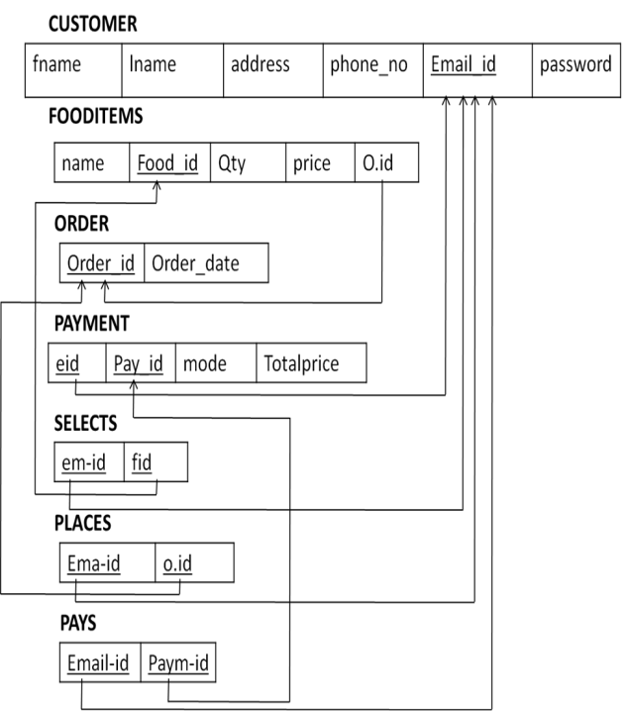

**Fig. 4.1(a)Initial Relational model from ER model,**

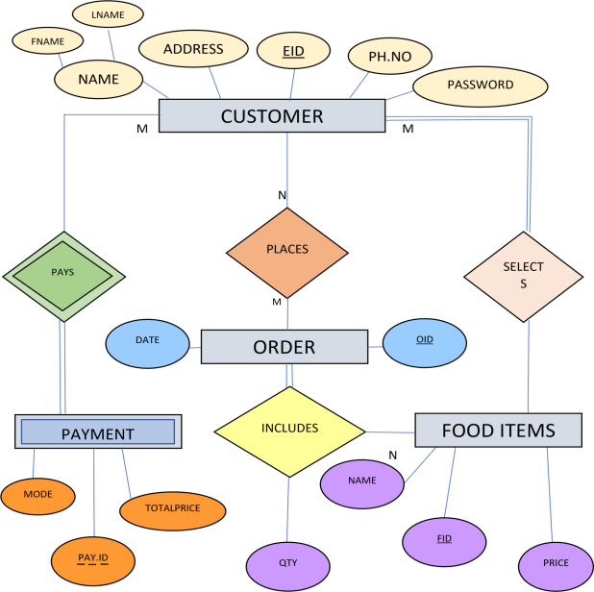

**Fig 4.2 (b) ER model representation of online food ordering system**

1. **DETAILS OF DESIGN, WORKING AND PROCESSES**

**HTML** (Hypertext Markup Language)

HTML is the most basic building block of the Web. It defines the meaning and structure of web content. Each page contains a series of connections to other pages called hyperlinks. Every web page you see on the Internet is written using one version of HTML code or another.

**CASCADING STYLE SHEETS** (CSS)

CSS is a simple mechanism for adding styles (e.g., fonts, colors, spacing) to Web documents. CSS defines how HTML elements are to be presented on screen, paper, or in other media. CSS saves a lot of work. It can control the layout of multiple web pages all at once.

**JSP:**

Java Server Pages (JSP) is a server-side programming technology that enables the creation of dynamic, platform-independent method for building Web-based applications. JSP have access to the entire family of Java APIs, including the JDBC API to access enterprise databases. This tutorial will teach you how to use Java Server Pages to develop your web applications in simple and easy steps.

**TOMCAT SERVER:**

Server refers to a software stack for the Microsoft Windows operating system, created by Romain Bourdon and consisting of the Apache web server, MySQL database and PHP programming language.

The database language used in our project,

**MySQL:** MySQL is a relational database management system based on SQL – Structured Query Language. The most common use for MySQL, however, is for the purpose of a web database. Standard SQL commands such as ADD, DROP, INSERT and UPDATE can be used in MYSQL.

**Advantages of MySQL**:

* High speed, using the SQL queries, the user can quickly and efficiently retrieve a large amount of records from a database.
* In the SQL standard, it is very easy to manage the database system.

**Data Flow Diagram:**

A data flow diagram (DFD) maps out the flow of information for any process or system. It uses defined symbols like rectangles, circles and arrows, plus short text labels, to show data inputs, outputs, storage points and the routes between each destination. Data flowcharts can range from simple, even hand-drawn process overviews, to in-depth, multi-level DFDs that dig progressively deeper into how the data is handled. They can be used to analyze an existing system or model a new one. Like all the best diagrams and charts, a DFD can often visually “say” things that would be hard to explain in words, and they work for both technical and nontechnical audiences, from developer to CEO. That’s why DFDs remain so popular after all these years. While they work well for data flow software and systems, they are less applicable nowadays to visualizing interactive, real-time or database-oriented software or systems.

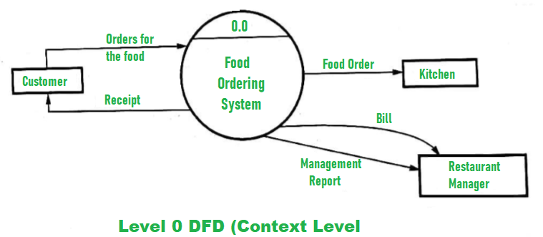

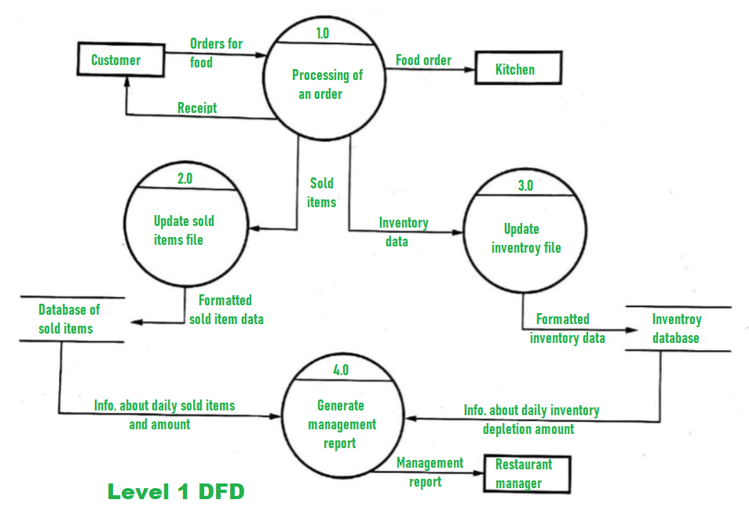

**Flowchart :**

Mess Detail

Food, Mess

About Contact Gallery

Login

Admin LogIn

Add Mess

Add Food

Manage Product

Order Detail

User Detail

**False**

**True**

FeedBack

**ER-Model :**



**ER model representation of online food ordering system**

**Documentation Testing:**

Documentation Testing involves testing of the documented artifacts that are usually developed before or during the testing of Software.

Documentation for Software testing helps in estimating the testing effort required, test coverage, requirement tracking/tracing, etc. This section includes the description of some commonly used documented artifacts related to Software development and testing

**Performance Testing:**

Performance Testing is defined as a type of software testing to ensure software applications will perform well under their expected workload.

Features and Functionality supported by a software system is not the only concern. A software application's performance like its response time, reliability, resource usage and scalability do matter. The goal of Performance Testing is not to find bugs but to eliminate performance bottlenecks.

**Database Testing:**

Database testing involves the retrieved values from the database by the web or desktop application. Data in the User Interface should be matched as per the records are stored in the database.

1. **RESULTS AND APPLICATIONS**

**Home Page :**

This is Home, where user can see the food information which is categorized by Food section and Mess Section.

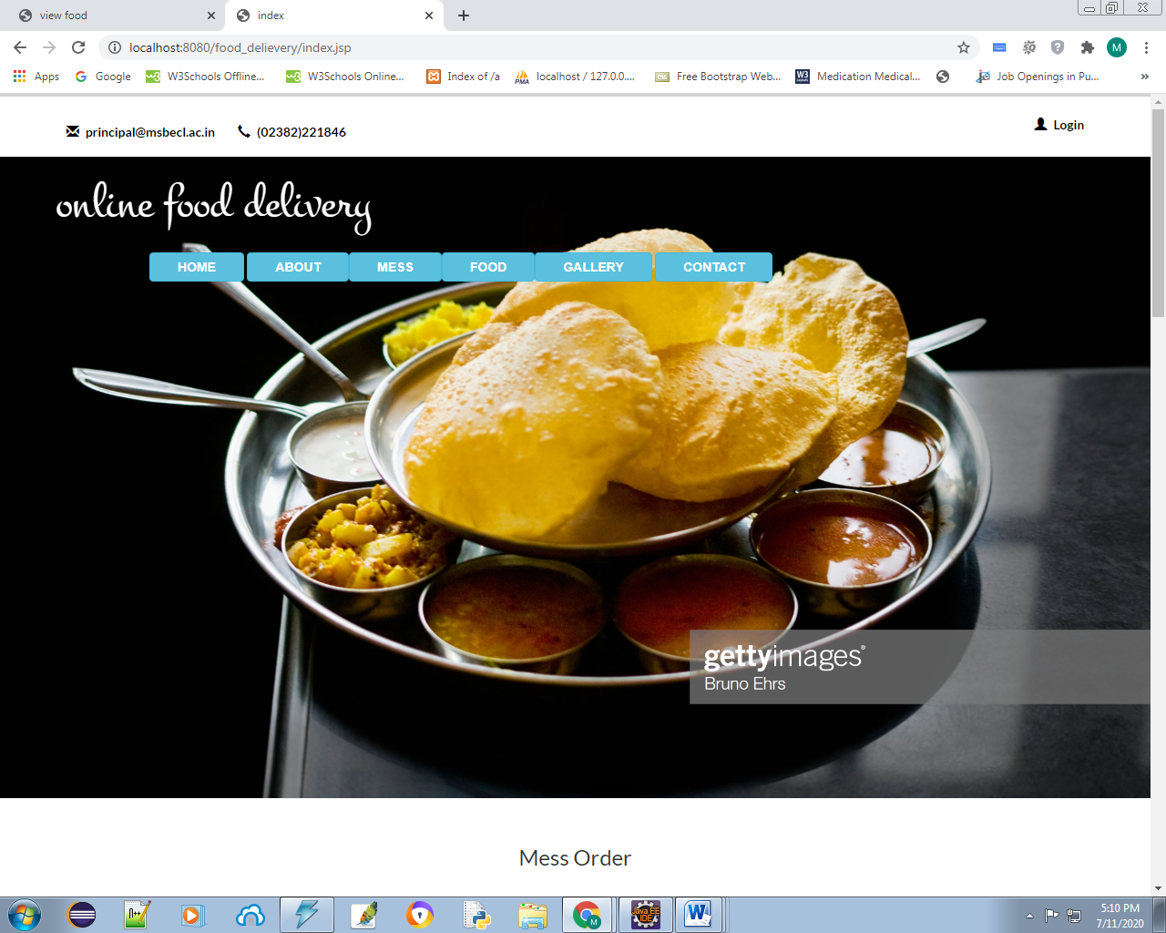

**About:**

This is About page, Where user can see the information about the shop

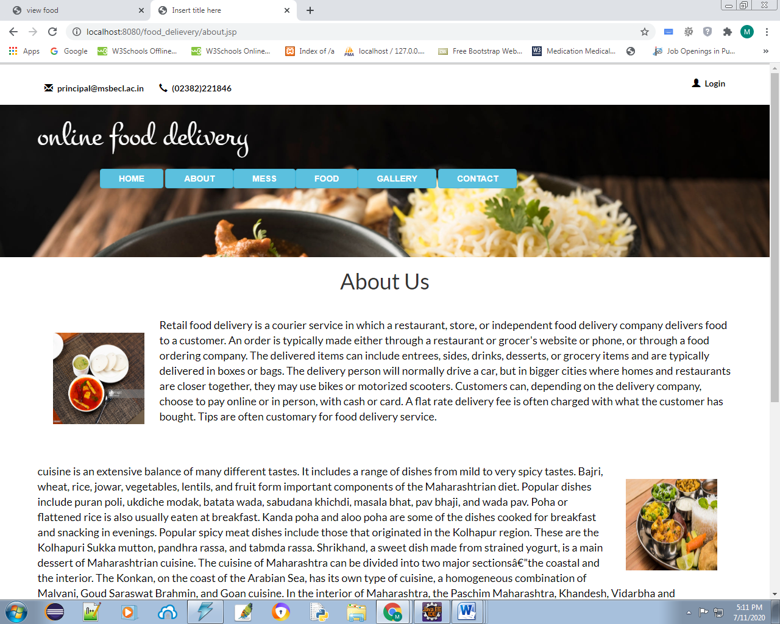

**Mess:**

In Mess Section User can browse the foods which is related to mess.

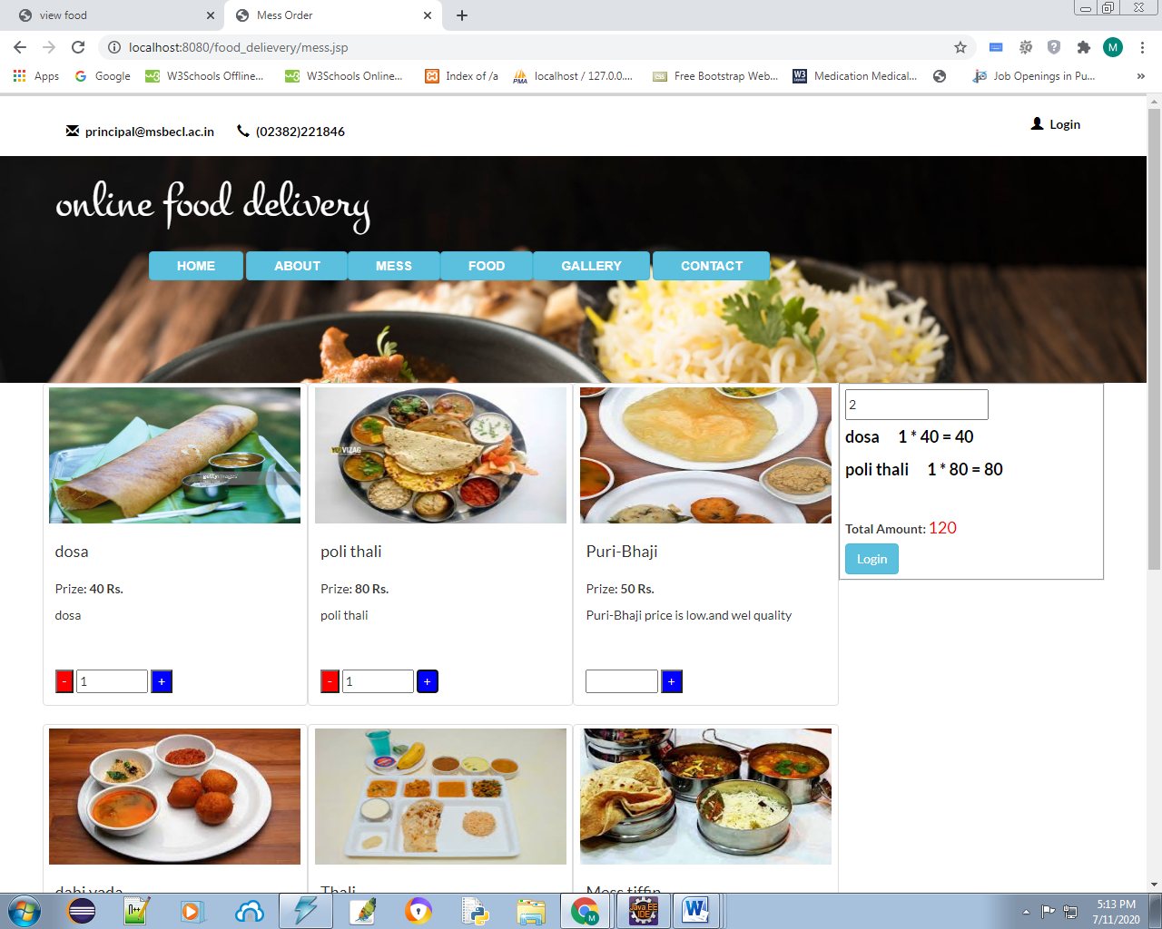

**Food:**

In Food Section User can browse the foods which is related to Food.

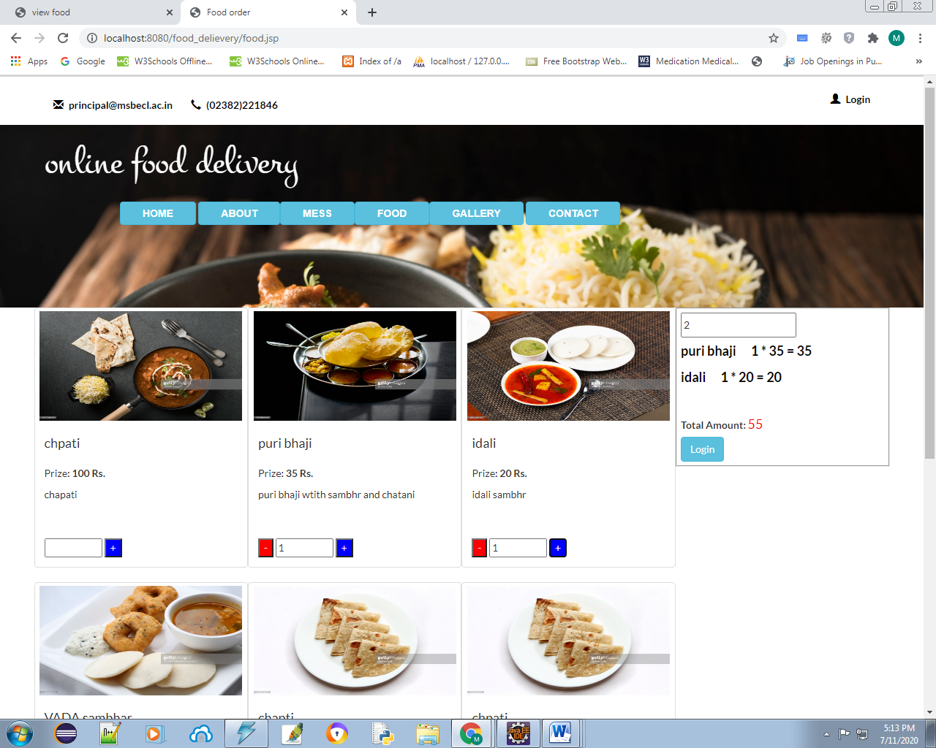

**Gallery:**

Here can user see the foods image which is made in the shop.

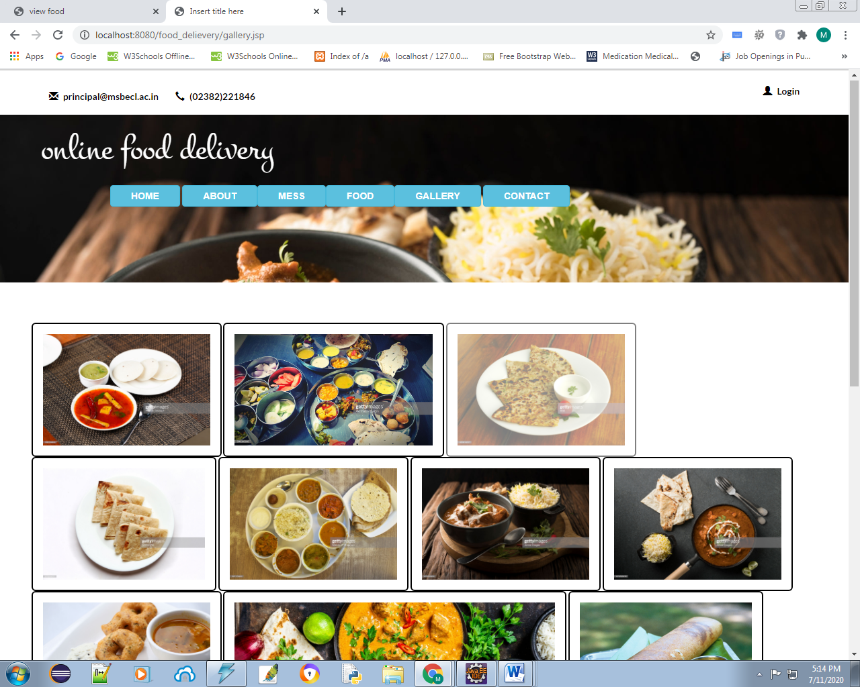

**Contact:**

Contact page, Here can use can contact with shop owner by various method, calling and Sending feedback form.

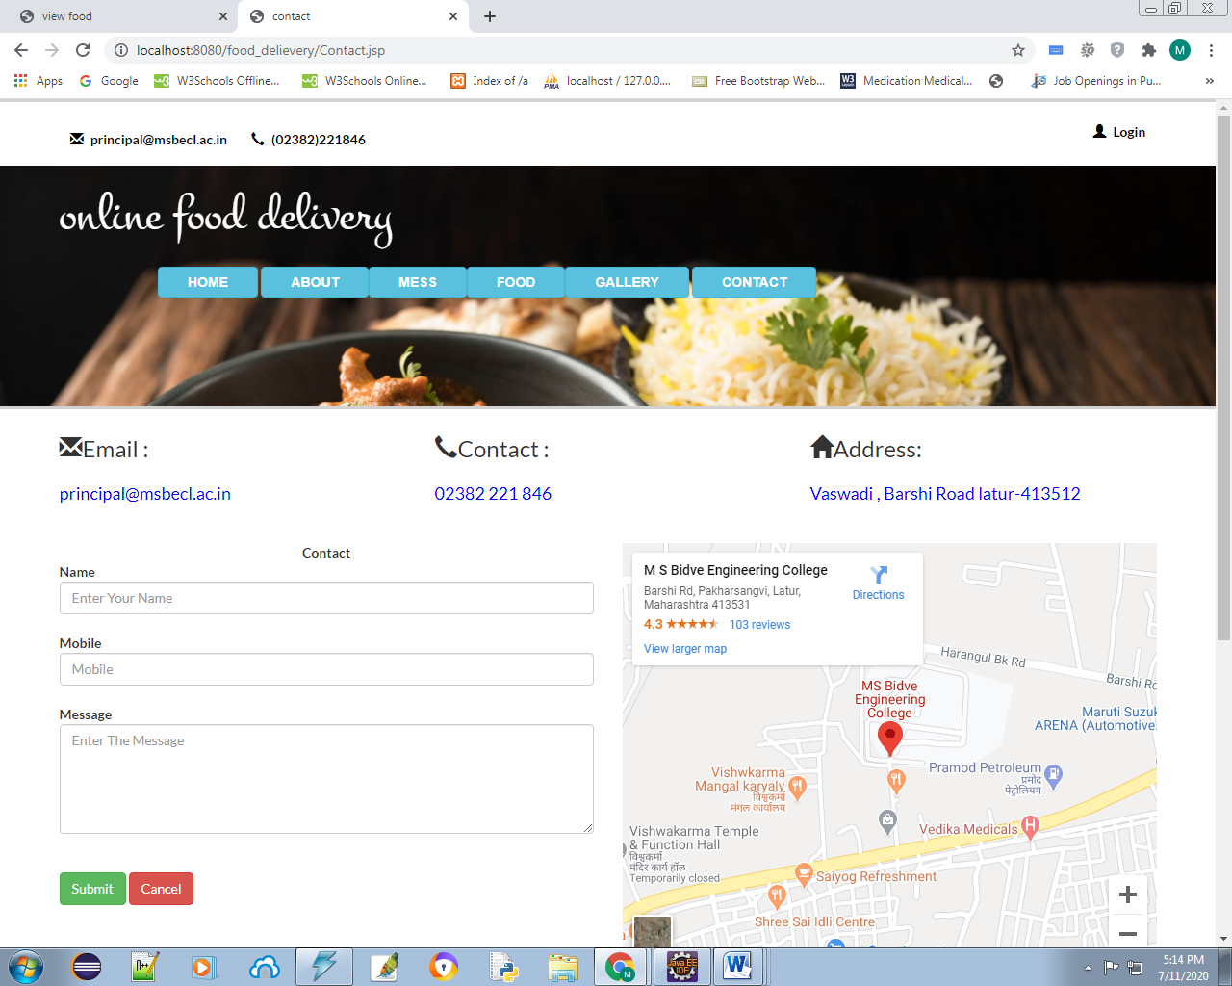

**Login and Registration:**

Here User can create or login their user Account with filling the detailed Information .

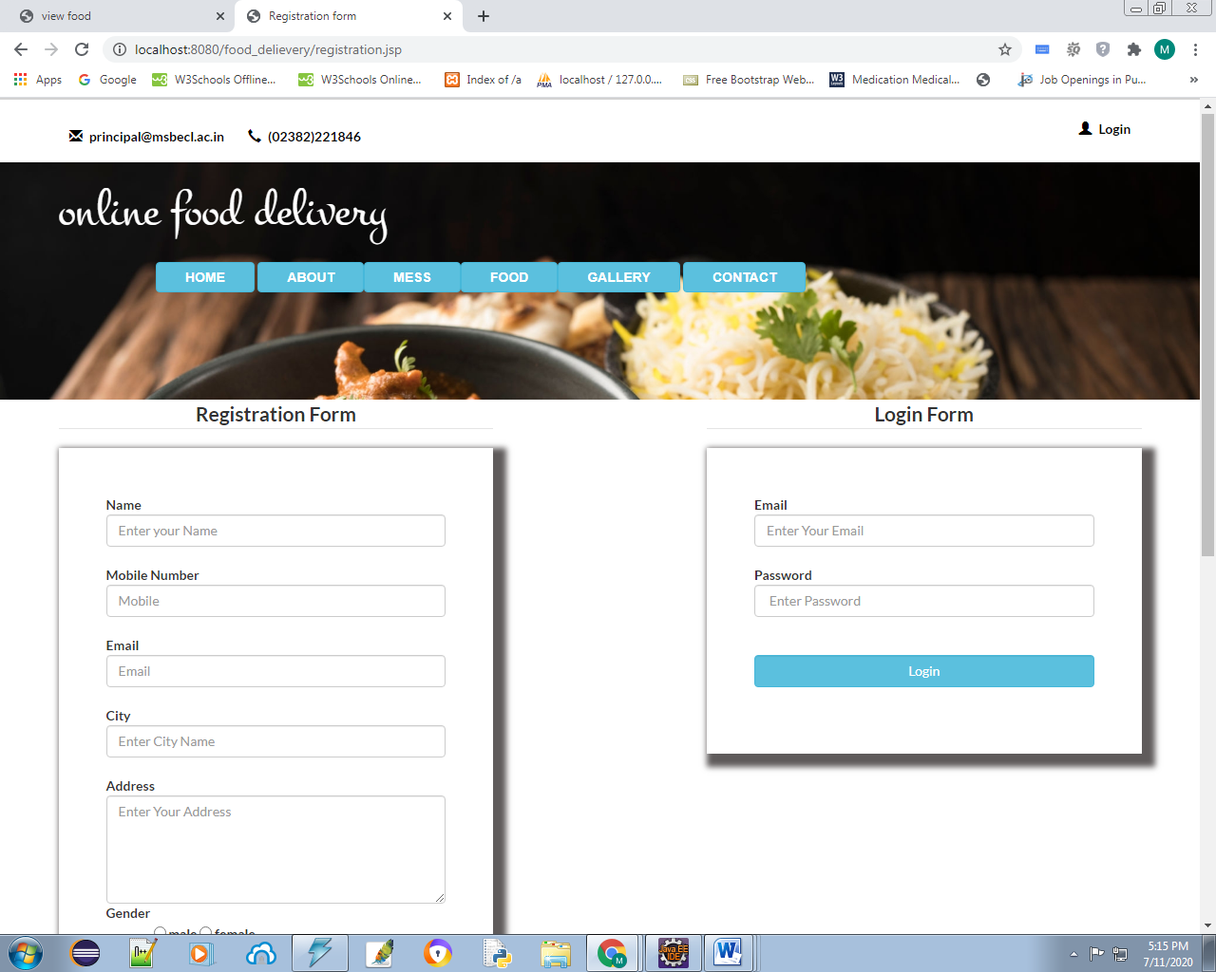

**Admin Side :**

**Admin Login:**

This login page for only use for Admin, they can login by entering the correct username and password.

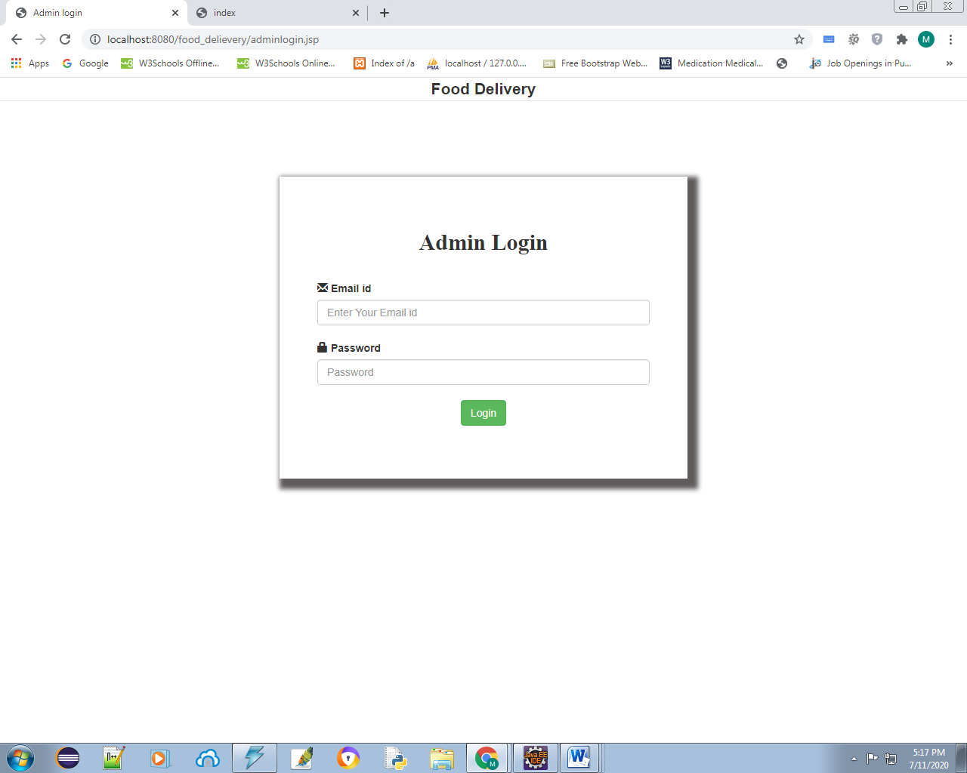

**Add Food:**

Here can admin add the details about the food like name, photo, price, description.

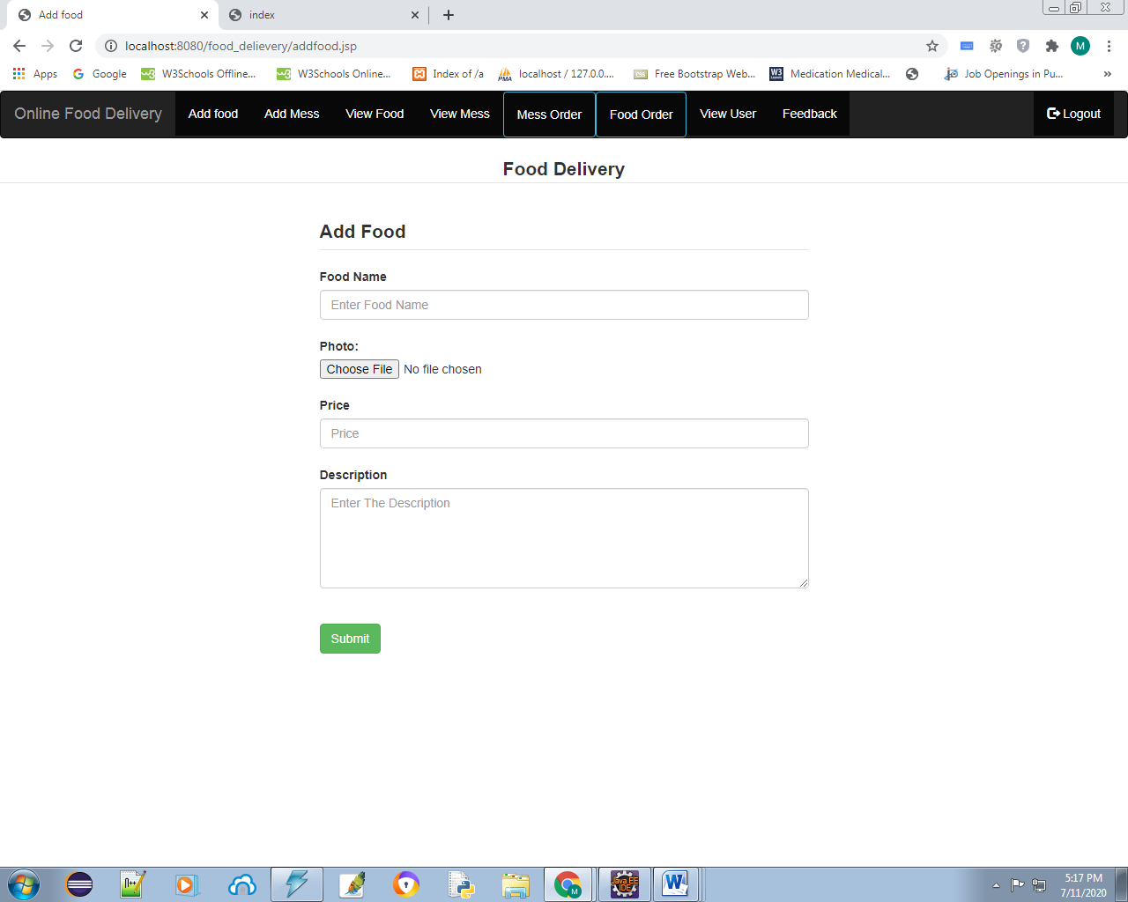

**Add Mess:**

Here can admin add the details about the Mess food like name, photo, price, description.

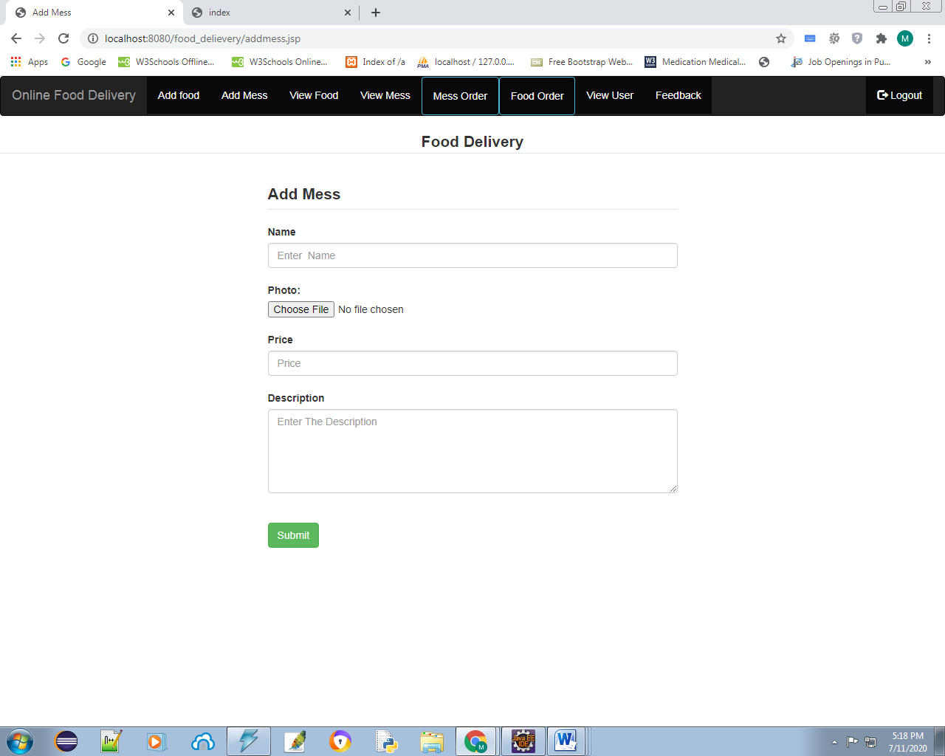

**View Food:**

Here can admin see the details about the food like name, photo, price, description and also edit the details.

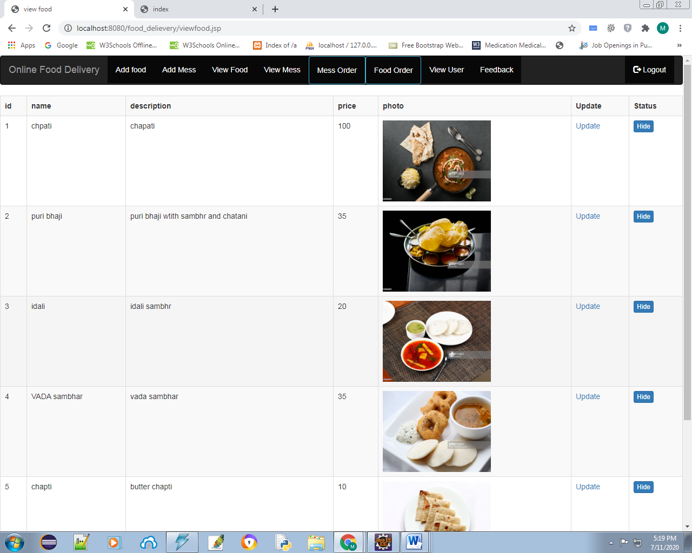

**View Mess:**

Here can admin see the details about the Mess food like name, photo, price, description and also edit the details.

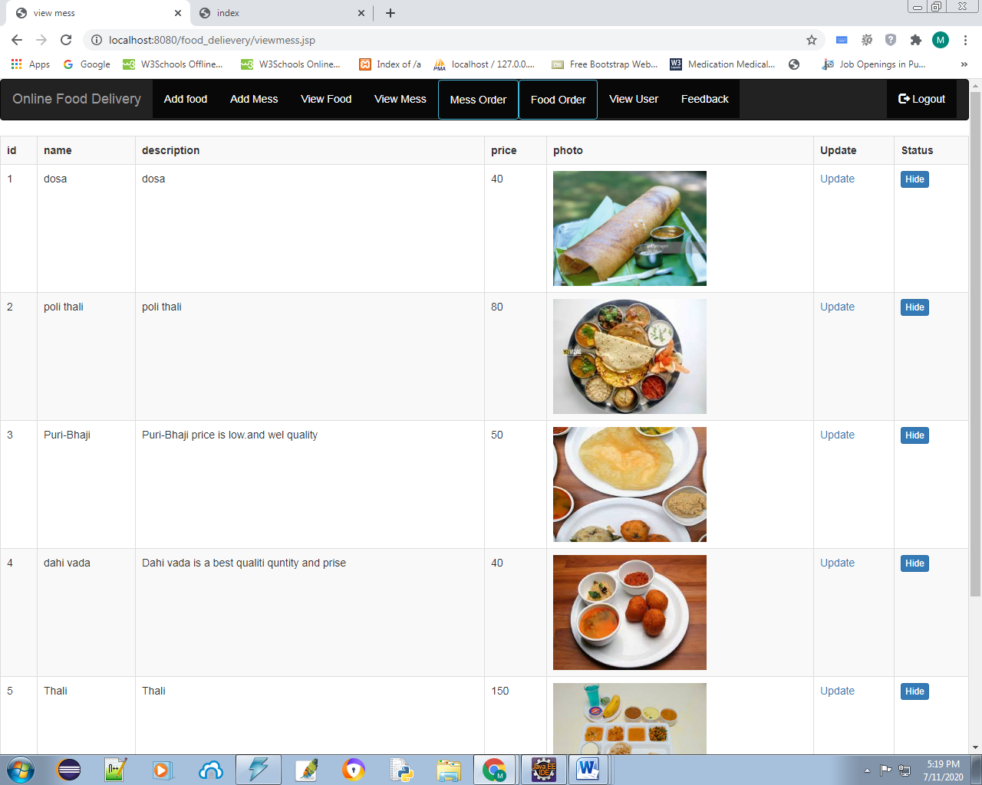

**Mess Order Detail:**

Here admin can see the Mess Food related orders details.

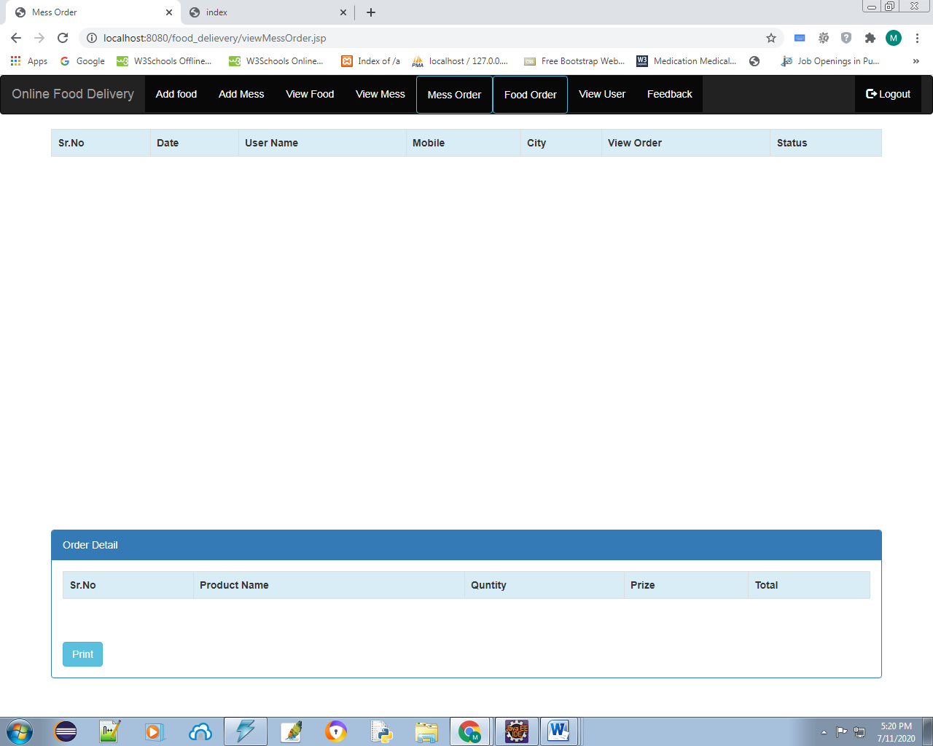

**Food Order Detail:**

Here admin can see the Food related orders details.

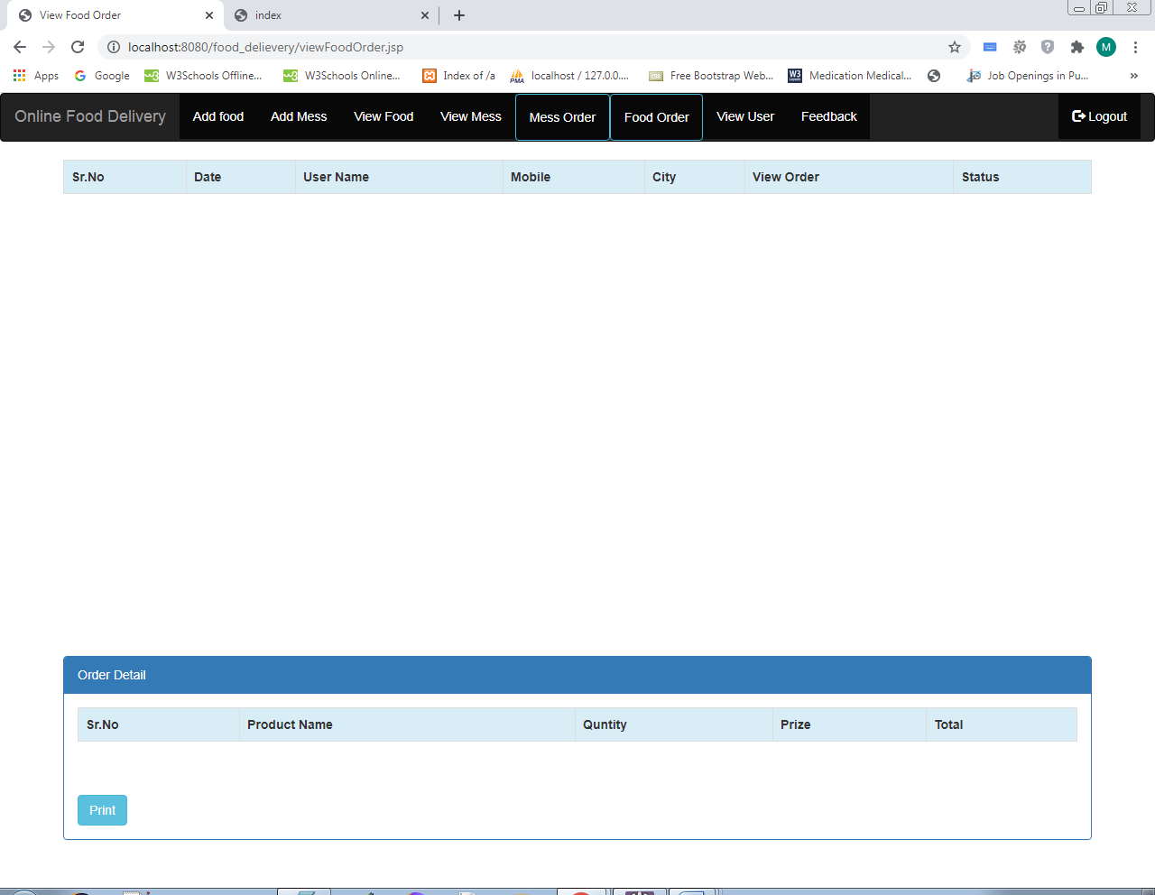

**FeedBack:**

Here admin can see the details about user feedback and their querys.

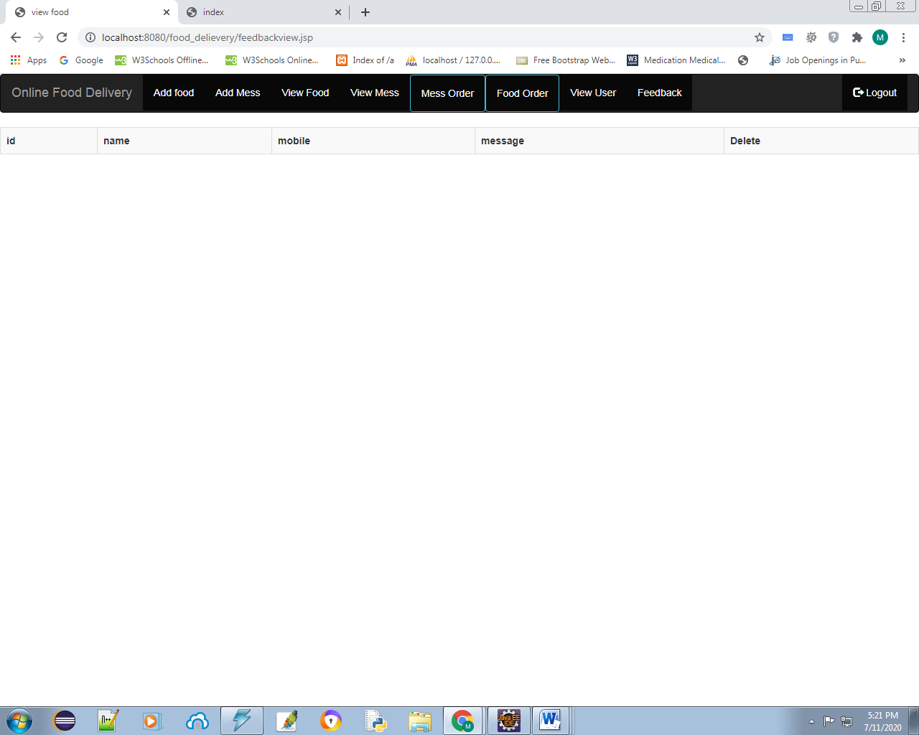

1. **CONCLUSION AND FUTURE SCOPE**

The conclusion and recommendations part summarizes the whole report by highlighting all the chapters and their significance and the importance of the project and the achievements.

In conclusion an online food ordering system is proposed which is useful in small family run restaurants as well as in places like college cafeteria, etc. This project can later be expanded on a larger scale. It is developed for restaurants to simplify their routine managerial and operational task and to improve the dining experience of the clients. This also helps the restaurant owners develop healthy customer relationships by providing reasonably good services. The system also enables the restaurant to know the items available in real time and make changes to their food and beverage inventory based on the orders placed and the orders completed.

**REFERENCES**

1. Awojide, Simon, I. M. Omogbhemhe, O. S. Awe, and T. S. Babatope, “Towards the digitalization of Restaurant Business Process for Food Ordering in Nigeria Private University: The Design Perspective. A Study of Samuel Adegboyega University Edo State Nigeria,” Int. J. Sci. Res. Publ., vol. 8, no. 5, pp. 46–54, 2018.

2. O. I. Mike and A. Simon, “Towards the Digitalization of Hotel Business in Nigeria: The Design Perspective,” vol. 8, no. 2, pp. 1175–1178, 2017.

3. Adithya. R., A. Singh, S. Pathan, and V. Kanade, “Online Food Ordering System,” Int. J. Comput. Appl., vol. 180, no. 6, pp. 22–24, 2017.

4. Varsha Chavan, Priya Jadhav, Snehal Korade, Priyanka Teli, ”Implementing Customizable Online Food Ordering System Using Web Based Application”, International Journal of Innovative Science, Engineering Technology(IJISET) 2015.

5. Patel, Mayurkumar, "Online Food Order System for Restaurants" (2015). Technical Library. Paper 219.

6.JSP code [online] available at www.w3schools.com 7. mysql code [online] available at www.stackoverflow.com